**Mayor’s Resilience Fund**

**TECHNICAL GUIDANCE**

**REGISTERING ON GLA-OPS**

1. **Registering on GLA-OPS**

To use GLA-OPS you must register your organisation and its users against at least one GLA department or MOPAC. If you have already registered, you can login at <https://ops.london.gov.uk>.

* 1. **Register Organisation**

If your organisation is not yet registered on GLA-OPS, you will need to register following these three steps (if it is, jump to 1.2):

* First, navigate to <https://ops.london.gov.uk/> in your web browsers. We recommend you use Internet Explorer or Google Chrome which are both supported.
* Second, click on ‘New to GLA-OPS? Register here’ then ‘Register an Organisation’.

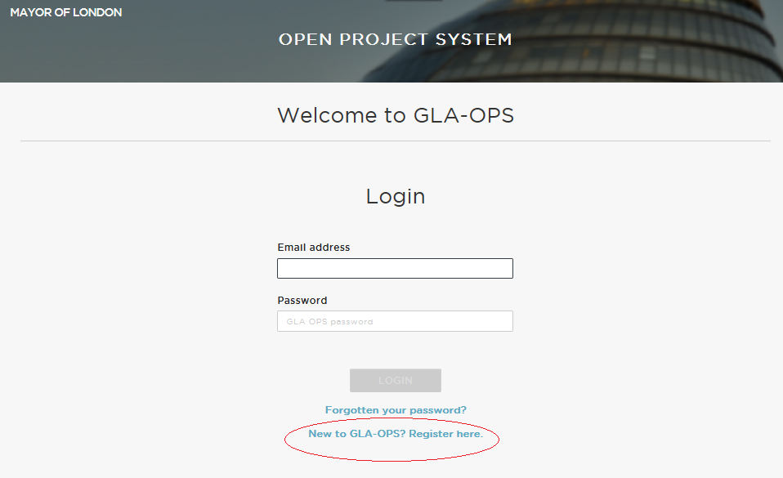

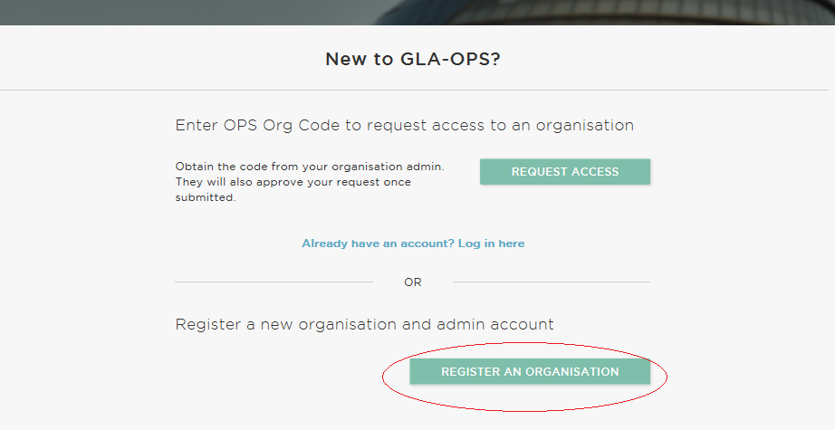

* Third, choose ‘Mayor’s Resilience Fund’ programme under the ‘GLA Regeneration Unit’ to start the registration
* Fourth, complete the webform and click ‘Request New Profile’.

If your organisation will be delivering projects for multiple departments, you can create additional profiles, once your initial request has been approved (see 1.5).

Your request will then be reviewed by the GLA Team you have registered against and either approved or rejected.

Note, the user registering your organisation will become the ‘Org Admin’ for your organisation once the request is approved.

This means they will be responsible for:

* + Keeping your organisation’s details up-to-date
  + Approving new users from your organisation
  + Assigning each user in your organisation a role (including assigning additional admins)

The person submitting the new organisation request must therefore have authority within your organisation to carry out the above tasks.

* 1. **Register User**

If your organisation is already registered on GLA-OPS, you can gain access by contacting your ‘Org Admin’. They will provide you with your organisation’s registration key which you will need when registering. They will also approve your request and assign you a role.

The registration key can be found by clicking ‘Organisations’ from the menu bar, then ‘Manage Organisations’, and then on the name of your Organisation. Organisation admins can update the registration key at any time by clicking ‘edit’.

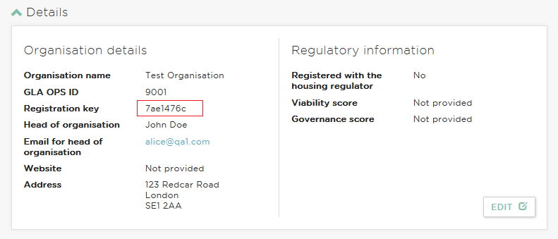

If you do not know if your organisation is registered or who your Org Admin is contact [innovation@london.gov.uk](mailto:innovation@london.gov.uk) who will be able to look this up for you or email [ops@london.gov.uk](mailto:ops@london.gov.uk) with your organisation name and legacy system code if you have one.

The user registration process in GLA-OPS has been streamlined based on user feedback to provide an improved user experience and to ensure providers are in complete control over who has access to their organisation.

To register you will need to follow three simple steps:

* First, navigate to <https://ops.london.gov.uk/> in your web browsers.
* Second, click on ‘New to GLA-OPS? Register here’ then select ‘Request Access’



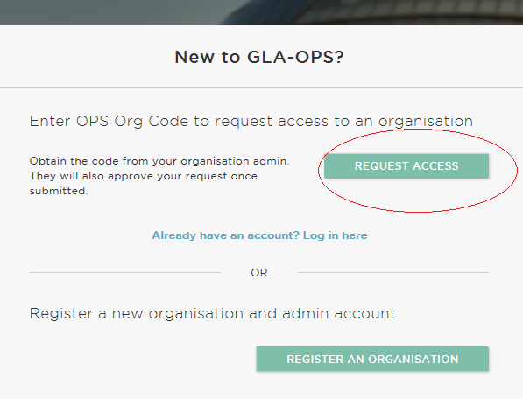

* Third, complete the webform and click ‘Register’

An email will automatically be sent to users within your organisation who have been assigned the ‘Org Admin’ role. They will approve your request and assign you a role.

**1.3 Reset your Password**

If you have forgotten your password, on the login page click on:



You will then be directed to the reset password screen. Enter your email address and click on:



You will receive an email with a link to reset your password. Follow the details on this screen to reset your password and then return to the login screen.

**1.4 Request access to multiple organisations**

If you are already registered on GLA-OPS against one organisation but need access to another (for example, you are a consultant working for multiple organisations / or your organisation is bidding for funding across departments), you can also request access by logging into the system and clicking ‘Organisations’ from the menu bar, then ‘Manage Organisation’ then by clicking the ‘Request Access’ button.

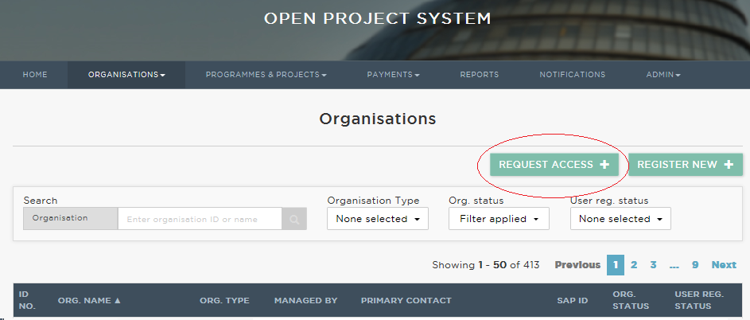

You will need to enter the registration key for the organisation profile you are requesting access. The Org Admin for the organisation will be able to provide you with this code.

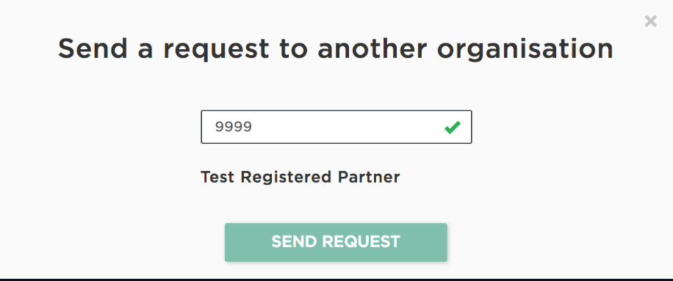

* 1. **Creating multiple organisation profiles**

Your organisation will have been registered against a specific department, for example, GLA Housing & Land or GLA Culture. If you would like to bid for funding in a different department, you will need to create a new organisation profile if you do not already have one.

You can create a new profile by clicking ‘Organisations’ from the menu bar, then ‘Manage Organisation’, then clicking ‘Create New Profile’.

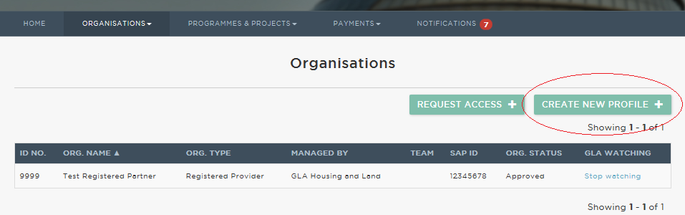

You will then be asked to complete a webform and to select the relevant department. Once complete, click ‘Register New’. Your request will then be sent to the relevant department for approval.

Note, the user making the request will become the profile’s ‘Org Admin’ once the request is approved. This means they will be responsible for helping other users register against the profile and assigning them a role.

Once the registration request has been approved, the Org Admin for that profile should share the registration key with users who require access. These users should then follow the steps outlined in step 1.4.

**CREATING A PROJECT**

**Creating and submitting projects in OPS**

This section provides guidance on how to submit an application for the Mayor’s Resilience Fund. You will need to create a project in order to submit an application.

**Create a Project**

* To create a project, go to:



* and click on



* then click on



The ‘Enter project details’ screen will then be displayed:

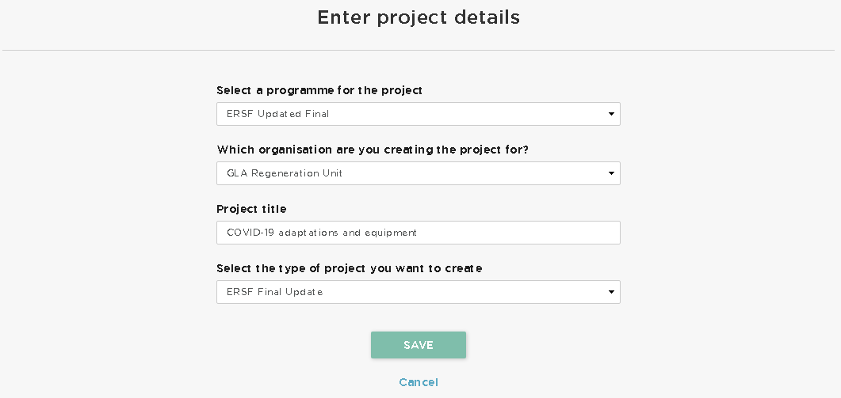

* From the programme dropdown, select Mayor’s Resilience Fund
* Select your organisation from the dropdown.
* Enter the name of your project. Please use your company name.
* Select the type of project you want to create – select Mayor’s Resilience Fund.
* Once the fields have been completed, select 
* This will generate a unique Project ID and will take you to the project overview page.
* This section will include Project title, Bidding Arrangement, Programme selected (Mayor’s Resilience Fund) Project type (Mayor’s Resilience Fund). You will see these fields then all pre-populate the Project Details section of your application (Block 1) – see next section for further information.

**APPLICATION BLOCKS**

The application process then follows with each area of information required set within a block. Complete the blocks referring to this guidance/

There are four blocks to complete, which can be completed in any order. Click on each block to access it and complete all sections before submitting your funding bid.

On every block you will need to click  at the top right of the screen in order to input or amend information.

Optional questions are flagged and all the others are mandatory. You may save a project at any time and return to it later.

Click  to save the information you have entered then click  to return to the main application block screen above.

If a mandatory field has not been completed, the system will allow you to continue but you will not be able to submit a project until all the blocks show as:



**BLOCK 1**

**PROJECT DETAILS**

The Project title, Bidding Arrangement, Organisation name, Programme selected, Project type selected are all pre-populated through the details inputted when you originally created the new project in OPS.

The project’s title can be edited here if required. This should be your company name.

You should also enter the address of the project and confirm the main contact and email address. (Note that when you enter the organisation’s name this will auto populate the main contact name and email address with your details. If you are creating the project on somebody else’s behalf ensure to update these details accordingly). Optionally, you can add a secondary contact.

Once completed, click then click  to return to the main application block screen.

**BLOCK 2:**

**ORGANISATION DETAILS**

**Organisation Details**

We will need to confirm what your job title is and if you are applying with any co-applicants, and if so, who they are. We will also need to confirm that your business is State Aid compliant. Please note that the information icons expand to provide additional detail.

Once completed, click  then click  to return to the main application block screen.

**BLOCK 3**

**YOUR SOLUTION**

This block is where you outline what your solution, idea or proposal is in more detail, specially how it responds to the challenge you have chosen to apply, as set out on the [website](https://challenges.org/mayors-resilience/). Your answers in this block will be assessed by the judging panel.

In the first ‘Summary’ section, your answers should provide an overview of your solution and will help the judging panel to assess your solution against the suitability criterion. You can view the assessment criteria [here](https://challenges.org/mayors-resilience-entry-criteria/).

Please note that the information icons expand to provide additional detail.

The questions in the next ‘Impact’ section relate to the Impact judging criterion. Solutions should make a meaningful and sustained impact for the challenge’s target end users.

You should then demonstrate how your solution is innovative. This question relates to the Innovation judging criterion.We expect solutions to integrate and build on existing best practice, and to offer something that is different to or better than existing solutions.

These questions relate to the Feasibility judging criterion.

Finally, the last few questions relate to the Capability judging criterion. Your team and organisation should have the track record, skills, experience and resources (including partnerships) to successfully adapt and scale your solution.

Once completed, click then click  to return to the main application block screen.

**BLOCK 4**

**DECLARATION**

To be completed by the nominated Team Leader.

